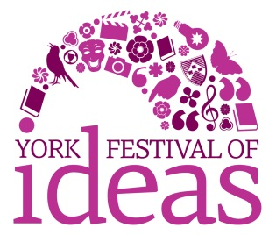
Innovation Fund application form
Your name
Organisation/group name if applicable
Email address
Phone number
Tell us about the activity you’re planning:
What will you do?
How does this support and enhance the Festival’s theme of Secrets and Discoveries?
Who will be involved in organising and running the activity?
Who is your target audience(s)?
How many people do you expect to take part?
How will your activity engage young people and/or harder-to-reach audiences?
How will you ensure your activity is accessible to these people?
How will you communicate with your target audience and publicise your activity? How will you be able to support the cross-promotion of York Festival of Ideas
Where will your activity take place? If you don’t yet have a venue confirmed, please tell us what sort of place you would like to use and how you will secure use of the space. The Festival team can advise on appropriate venues. Only activities based in the York area are eligible for funding.
When will your activity take place? Only activities taking place during the Festival period (9 to 21 June 2015) are eligible for funding.
Tell us about the timeline for planning and delivering your activity.
How much will your activity cost? What will the funding support?
What other sources of funding do you have? Please include approaches you plan to make as well as funding you have already secured.
How much money are you applying for from the Innovation Fund? The maximum grant available is £2,000. Most grants will be in the region of £1,000.

Applications must be kept on this form within two sides of A4 at a font size of no less than 10pt.
Please return this form by email to sarah.mitchell@york.ac.uk. Applications must be received by 5pm on Monday 15 December 2014.

